

**OFFICE OF THE PRESIDENT**

**TO : ALL CONCERNED August 13, 2020**

**SUBJECT : ADDITIONAL APPOINTMENTS**

The School Board is pleased to inform you of these additional appointments for Academic Year 2020-2021.

**BASIC EDUCATION**

**Elementary**

* PREFECT OF DISCIPLINE - MR. JOSEPH REX O. JABAL
* ACTIVITY PROGRAM COORDINATOR - MS. MARIA FRENCHIE VI A. REGINO

**JHS**

MRS. MARIA EDELYN S. GEONZON - PREFECT OF DISCIPLINE &

COORDINATOR OF STUDENTS FORMATION PROGRAMS

**SHS**

* PREFECT OF DISCIPLINE - MS. MARY NEL M. FERNANDEZ
* GRADE LEVEL COORDINATOR - MR. HERBEN M. TAUTHO
* QUIPPER LMS COORDINATOR - MRS. JOAN S. RAJAH

Please extend to them you usual kind support and cooperation so that they can effectively carry out their tasks, duties and responsibilities.

Thank you and God bless. Adelante!

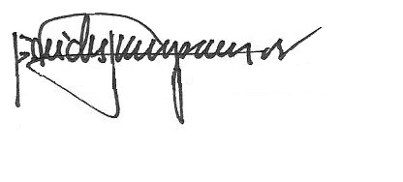

REV. FR. CRISTOPHER C. MASPARA, OAR

Pres